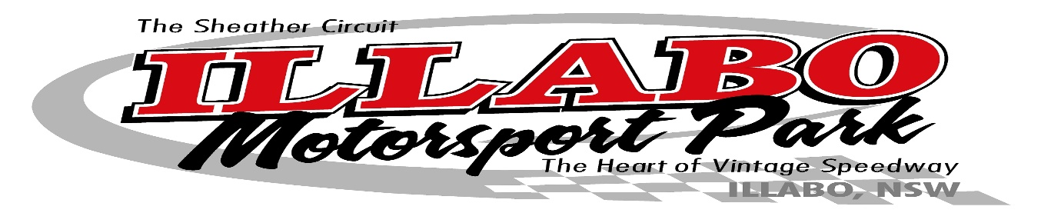
2020 Vintage Speedway Calendar
Saturday 7th March 2020
Saturday 9th May 2020
Saturday 1st August 2020
Saturday 17th October 2020
These events are operated by

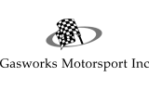
And

Proudly supported by
Sanctioned by
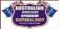
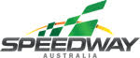
Illabo Motorsport Park is Sanctioned by the AVCSNB, NSW Dept. Sport & Rec License No: CORP14-6706 & issued a Speedway Australia Permit:
Entries are open to all Vintage Vehicles registered with the AVCSNB member clubs
The Australian Vintage Classic Speed Car National Body Constitution and Bi-Laws will apply to this event.

Further Information Contact: 0418-245-687

